Webservice Developement Schedule
Version: | 0.1
Author(s): | JE
Created: | 02/05/2009
Last modification: | 02/05/2009

Version | Date | Author(s) | Changes
0.1 | 02/05/2009 | JE | Initial version.
Contents
1. Team 1
2. Aim 2
3. Proceeding 2
3.1. Analysis 2
3.2. Specification 2
3.3. Design, Implementation and Test 2
4. Milestones 3

Team
The web service development team consists of three project members:
- Johannes Engelhardt (JE) (Team Guarantor)
- Reinhold Rumberger (RR)
- Aleksandar Tolev (AT)

External contact person:
- Ralph Mietzner (RM) (Customer)

Aim
The aim of this phase is to completely develop the following three web services as part of the DecidR project.
The three web services are:
- Data storage web service
- Email web service
- Human task web service

Proceeding
The Email WS depends on the data storage WS, the human task WS depends on both oder web services. Due to these dependencies, the web services will be developed (more or less) parallel.
As planned in the time schedule, from March 5th to 18th work will be stopped due to preparation for the exam on March 18th.

Analysis
A meeting with RM and the team is planned at Monday 9th, 14:00 to analyze the requirements on the web services precisely. The remaining days in the analysis phase are planned to complete and structure the requirements and, if necessary, get another feedback from the customer.

Specification
Each web service will be specified in an own document. There will be a short internal review and correction phase at the end of the specification phase. Reviews are intended to be internal. After completion, the specification will be sent to the customer for external review during the exam preparation time period.

Design, Implementation and Test
The design, implementation and test phase is planned after the exam and external specification review.
If the development of the web services proceeds as planned, it will be finished during the design phase of the main project, so the web services will be already completely available at this point.

Milestones
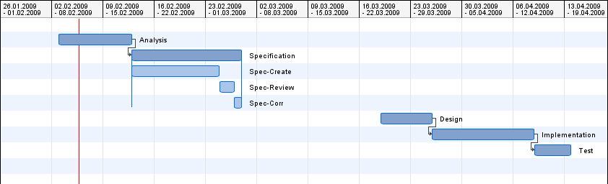

Developement Phases
Project Phase | Phase Begin | Phase End
1. Analysis | 03.02.09 | 12.02.09
2. Specification | 13.02.09 | 27.02.09
3. Design | 19.03.09 | 25.03.09
4. Implementation | 26.03.09 | 08.04.09
5. Test | 09.04.09 | 13.04.09

